Planting Legumes (peas and Beans) - As mentioned planting in rows is done for most plants, however others will need to be planted a little differently. Your peas and beans fall into this group. They will need individual planting at the base of some supports.

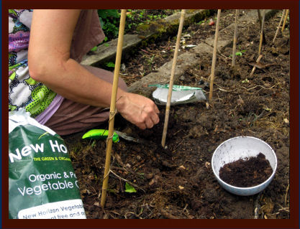

Beans being planted at the base of each support pole

Its important to remember that peas and beans (in this case runner and French beans) grow and climb differently.
- Beans will wrap themselves around almost anything near it and they will support themselves
- Peas grow small tendrils along its length that hook around objects. As long as they have something suitable to hook onto they will support themselves.

With the two points above in mind its important to get your support poles right. Runner beans as stated will climb up anything but the common thing to use is bamboo canes. You can buy these at garden centres or DIY stores. These can be arranged in a tepee shape or a line of triangles with a supporting mid cane. The thick end can be pushed in to the round and the other end tied with string to the opposing and mid cane. Runner beans grow to about 6-7ft so try to get your structure this high. You can also use string tied to a frame work or thin branches cut from trees.(Please don’t cut down from the countryside, ask a ranger at a local park if they have any cuttings or use your own or friends and family)
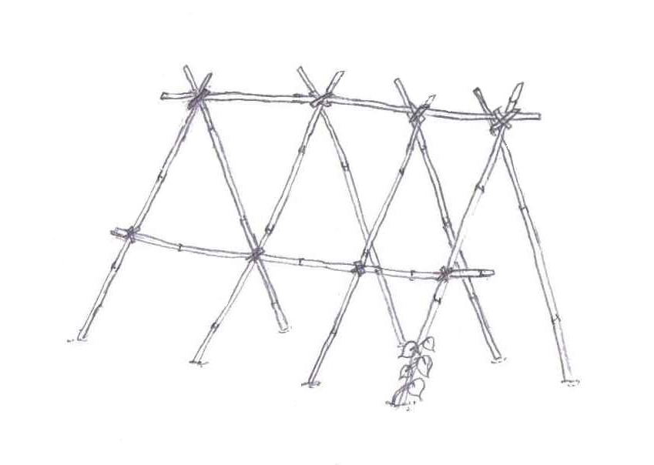

One type of structure that could be
used to grow runner beans

Peas will find bamboo canes too smooth with nothing for their tendrils to hook onto. So you can use ‘pea sticks’, which are literally sticks, or string tied to a frame work or even some old square fencing. Most peas will grow a lot shorter than runner beans (check back of packet for height) and therefore will only need sticks etc that are about 3ft high.

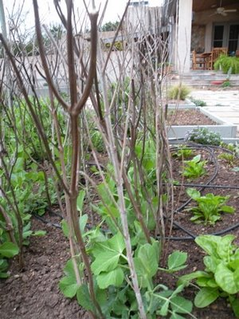
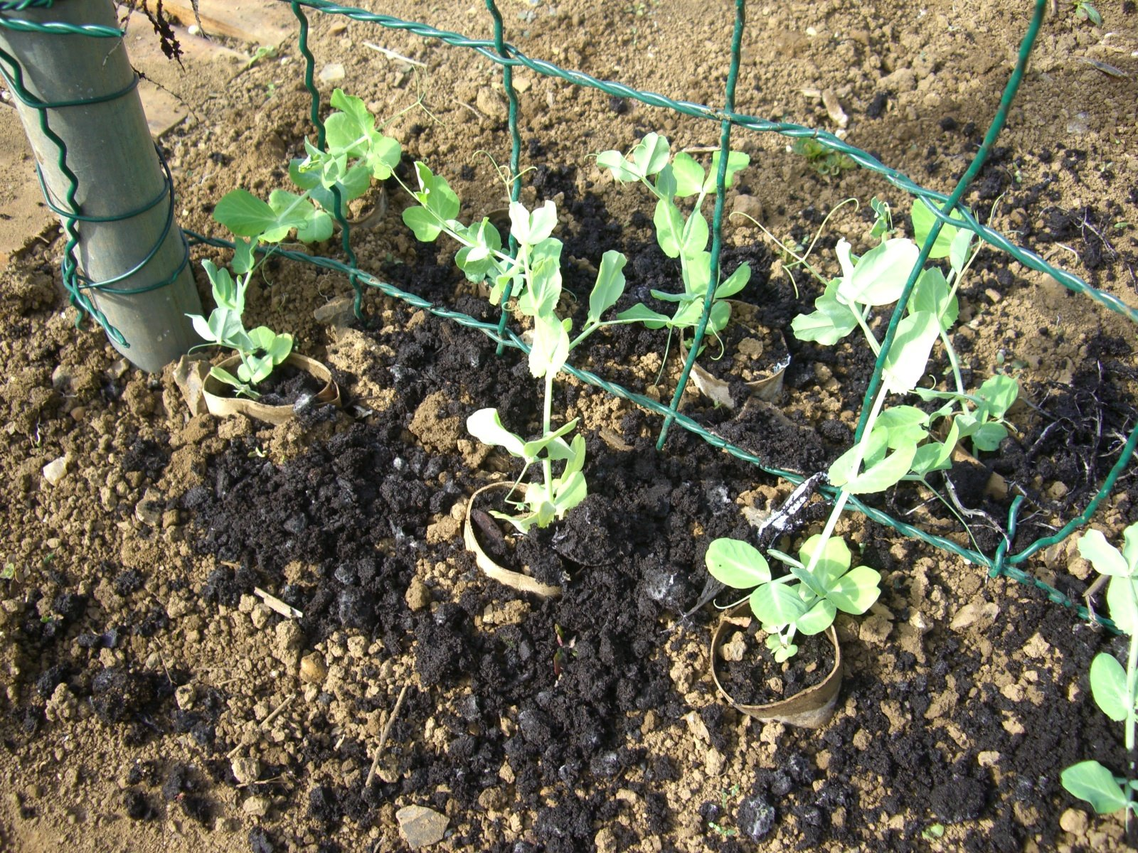

Peas growing up some fencing (note the loo rolls used, a good substitute for pots) permission given
Peas growing up pea sticks

Make sure you get the supports in first before the seeds or plants as you don’t want to damage anything by stabbing in a pole too close!

